Algorithm 5 DTLR algorithm

Input: | D, N
Output: | Defect prediction results
1. | K = Imbalance rate (D)
2. | ← IDT
3. | ← ISVM
4. | calculate 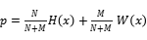
5. | if 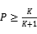 then
6. | y =1
7. | else
8. | y =0
9. | end if

